Technical vs Lay Synonyms

🔹 What is Technical vs Lay Synonyms
# Source: AI Source: Provided by: [Data Path: Persons Table -> ID Column: 1, Name_En Column: Motasem Essam] -> From: [Chatgpt (GPT-4-turbo)] on [7/30/2025]
Technical synonyms and lay synonyms are pairs of words that describe the same or similar concept but differ in specialization or audience. One is used in technical, academic, or professional contexts, while the other is used in everyday, general language.

🧠 Definition:
# Source: AI Source: Provided by: [Data Path: Persons Table -> ID Column: 1, Name_En Column: Motasem Essam] -> From: [Chatgpt (GPT-4-turbo)] on [7/30/2025]
Technical vs Lay synonyms refer to pairs of terms where one is specialized or jargon-based (technical) and the other is common or non-specialist (lay), though both refer to the same or similar thing.

📌 Key Features:
# Source: AI Source: Provided by: [Data Path: Persons Table -> ID Column: 1, Name_En Column: Motasem Essam] -> From: [Chatgpt (GPT-4-turbo)] on [7/30/2025]
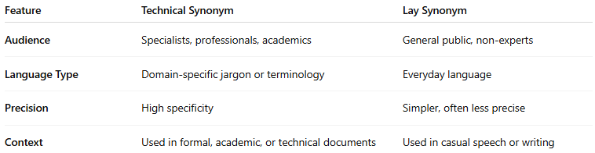
Feature | Technical Synonym | Lay Synonym
Audience | Specialists, professionals, academics | General public, non-experts
Language Type | Domain-specific jargon or terminology | Everyday language
Precision | High specificity | Simpler, often less precise
Context | Used in formal, academic, or technical documents | Used in casual speech or writing

📚 Examples of Technical vs Lay Synonyms:
# Source: AI Source: Provided by: [Data Path: Persons Table -> ID Column: 1, Name_En Column: Motasem Essam] -> From: [Chatgpt (GPT-4-turbo)] on [7/30/2025]
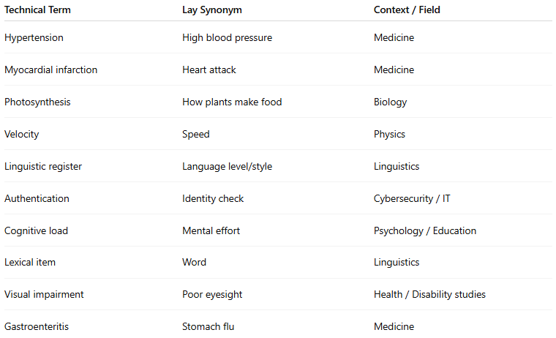
Technical Term | Lay Synonym | Context / Field
Hypertension | High blood pressure | Medicine
Myocardial infarction | Heart attack | Medicine
Photosynthesis | How plants make food | Biology
Velocity | Speed | Physics
Linguistic register | Language level/style | Linguistics
Authentication | Identity check | Cybersecurity / IT
Cognitive load | Mental effort | Psychology / Education
Lexical item | Word | Linguistics
Visual impairment | Poor eyesight | Health / Disability studies
Gastroenteritis | Stomach flu | Medicine

🔁 Comparison with Other Synonym Types:
# Source: AI Source: Provided by: [Data Path: Persons Table -> ID Column: 1, Name_En Column: Motasem Essam] -> From: [Chatgpt (GPT-4-turbo)] on [7/30/2025]
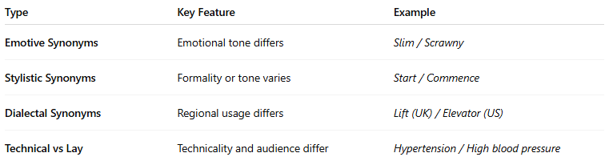
Type | Key Feature | Example
Emotive Synonyms | Emotional tone differs | Slim / Scrawny
Stylistic Synonyms | Formality or tone varies | Start / Commence
Dialectal Synonyms | Regional usage differs | Lift (UK) / Elevator (US)
Technical vs Lay | Technicality and audience differ | Hypertension / High blood pressure

🧾 Usage Note:
# Source: AI Source: Provided by: [Data Path: Persons Table -> ID Column: 1, Name_En Column: Motasem Essam] -> From: [Chatgpt (GPT-4-turbo)] on [7/30/2025]
- Lay synonyms are useful for communication with the general public, while technical terms are crucial for precision in expert fields.
- Translating technical terms into lay language is a key part of science communication, public health, and education.

